AI Powered Intelligent Hospital Patient Flow Management System
METHODOLOGY, NOVELTY AND KEY CONTRIBUTIONS

Student | Hall Ticket No.
A. RAMU | 23K91A6715
B. RUSHI | 23K91A6720
B. RAJ KUMAR | 23K91A6725
A. PRABHAS | 23K91A6703
Under the guidance of [GUIDE NAME]
Department of Computer Science and Engineering (Data Science)
[COLLEGE NAME]
[ACADEMIC YEAR]

1. Methodology Overview
CareFlow follows an evidence-driven patient-flow pipeline that begins with validated registration data and ends with a persisted operational state visible to each authorised role. The implementation combines deterministic workflow rules with two trained estimators: a triage classifier and a wait-time regressor. Predictions assist queue ordering and communication; they do not replace clinical judgement.
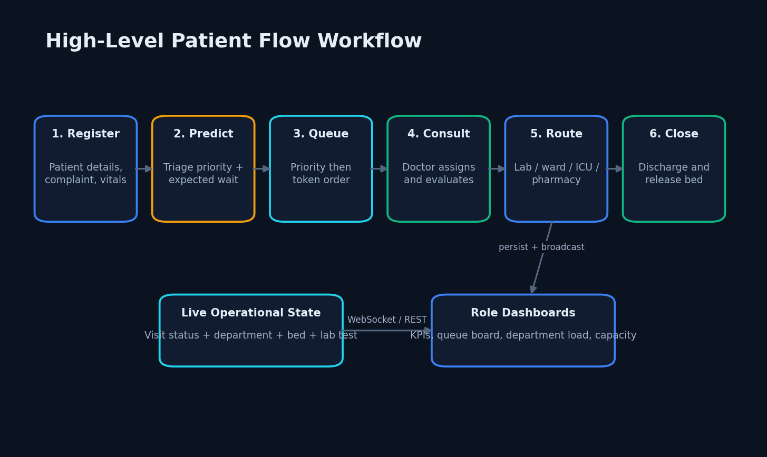
Figure 1. End-to-end patient-flow workflow.

2. Data Preparation
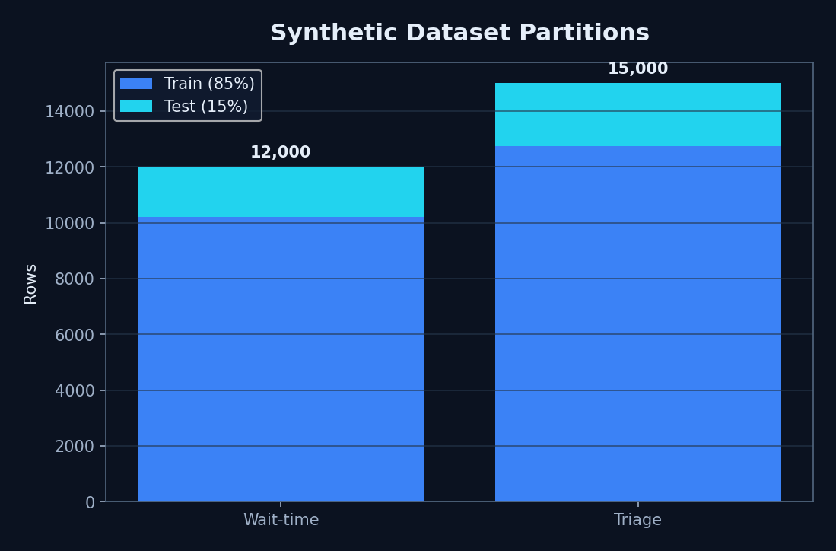
Figure 2. Synthetic dataset partitions.
The project does not use real patient records. The wait-time generator creates 12,000 rows from department mix, queue size, hour, priority, average service time and server count. The triage generator creates 15,000 vital-sign rows and assigns labels with a simplified NEWS2-style rule. Each dataset uses an 85/15 train/test split with random state 42.
Categorical department and priority values are label-encoded. Numerical features are kept on their original operational scales because tree ensembles do not require standardisation. Missing incoming vital values are replaced individually with documented defaults before inference.

3. Triage Classification
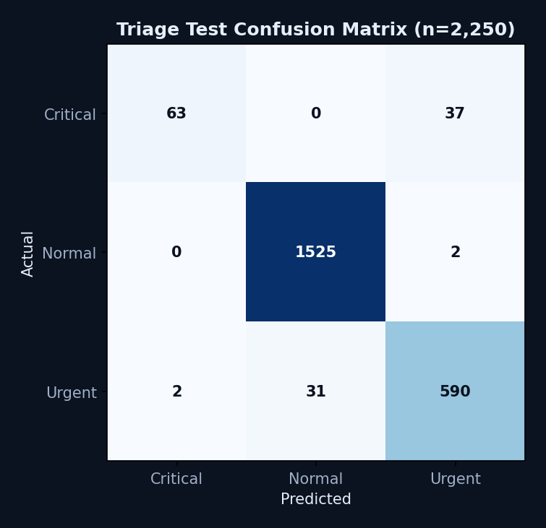
Figure 3. Triage confusion matrix.
The Gradient Boosting classifier consumes age, heart rate, systolic blood pressure, oxygen saturation, temperature and respiratory rate. It returns one of three priority classes—normal, urgent or critical—and the maximum class probability, which the current schema stores in the field named triage_score.
On the deterministic 2,250-row test partition the model achieved 0.9680 accuracy and 0.898475 macro F1. The critical-class recall was 0.63, so this model is an academic decision-support prototype and cannot be described as clinically validated.

4. Wait-Time Regression
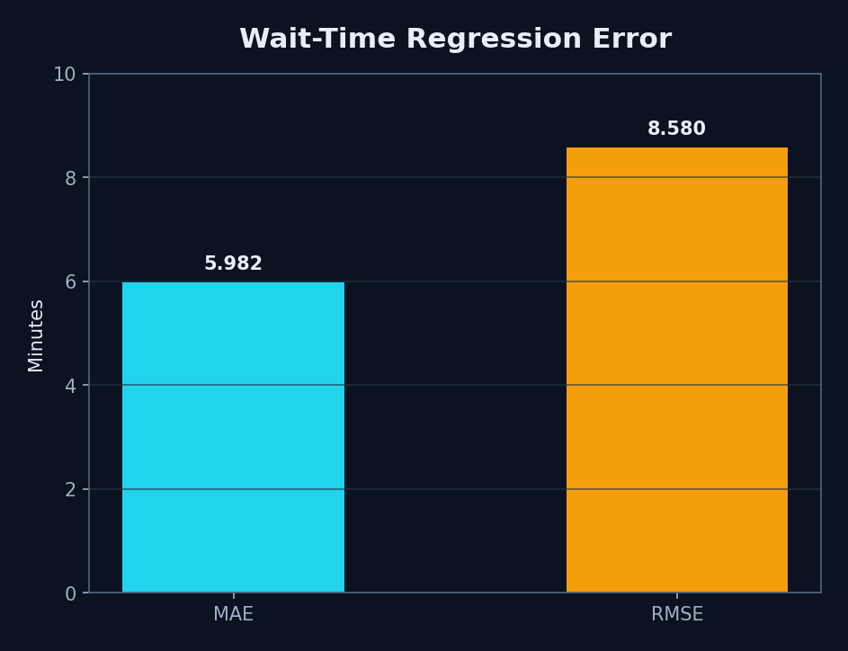
Figure 4. Wait-time error measures.
The Random Forest regressor estimates minutes from department type, patients ranked ahead, UTC hour, priority, average service duration and a default assumption of two servers. Training targets follow a queue-inspired formula with rush-hour and priority factors plus Gaussian noise, clipped to 0–240 minutes.
The measured test results were R-squared 0.951041, MAE 5.982 minutes and RMSE 8.580 minutes. These values describe recovery of a synthetic generator, not proof of real-world waiting-time reduction.

5. Operational Integration
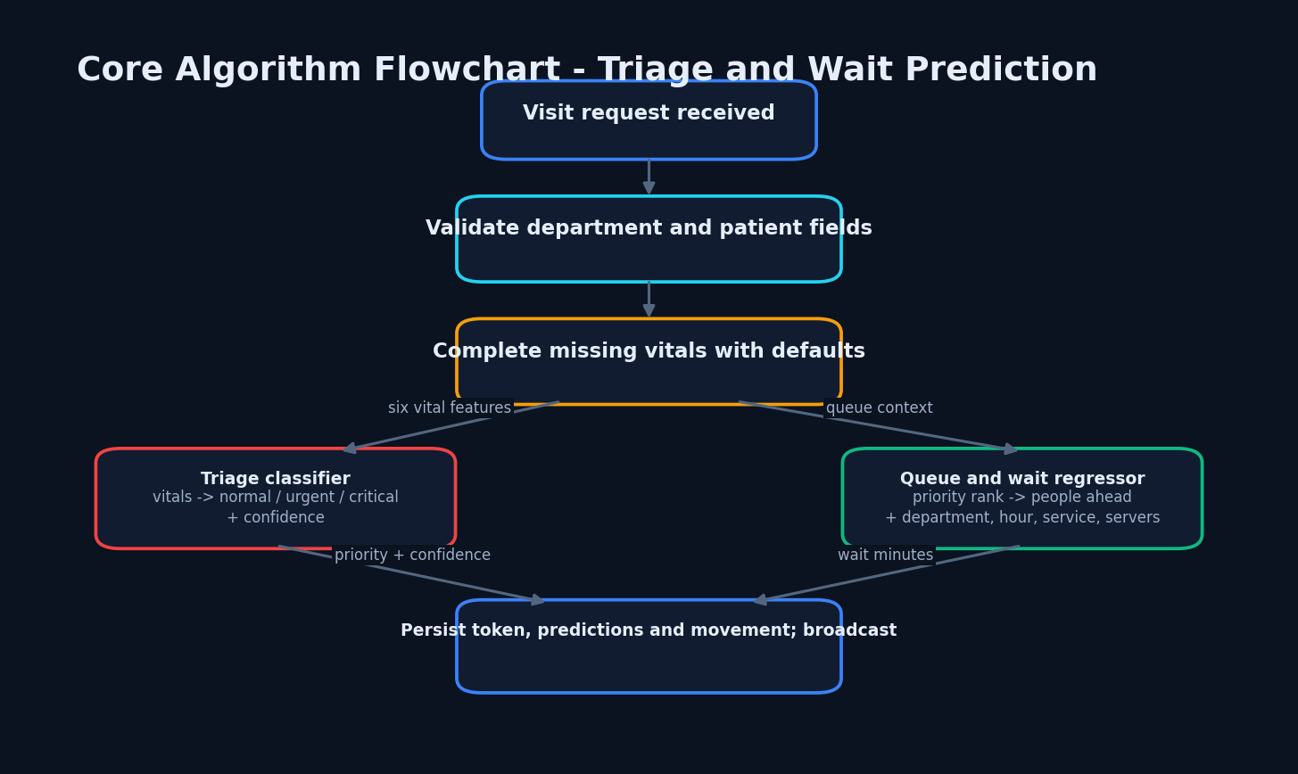
Figure 5. Core prediction and persistence algorithm.
During POST /api/visits, the service validates the department, finds or creates a patient, completes missing vitals, invokes both models, allocates the next department token, inserts a Visit and MovementLog, commits the transaction and broadcasts visit_created. Subsequent status or department changes create movement evidence and may recompute predicted wait.
Role restrictions are enforced with JWT decoding and require_roles dependencies. Doctors manage consultations and orders, laboratory technicians progress tests, nurses manage beds, reception creates visits and administrators view hospital-wide state.

6. Novelty
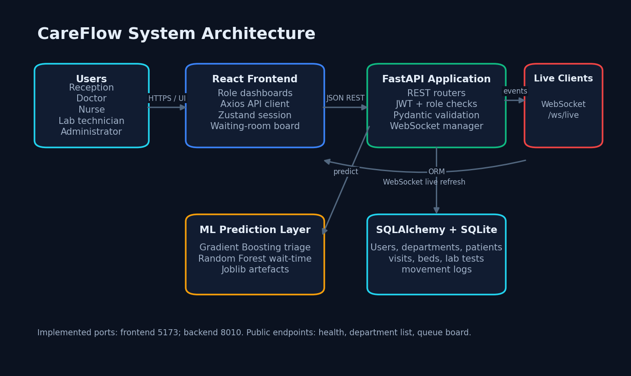
Figure 6. Integrated application architecture.
The novel contribution is not a new clinical scoring rule. It is the integration of priority-aware token ordering, explainable operational state, laboratory workflow, ward/ICU capacity and role-specific live dashboards in one compact prototype. Unlike the base paper, which focuses on patient-side personalised healthcare and recommendations, this system addresses coordination after a patient enters the hospital.
A second contribution is honest evidence separation: synthetic model evaluation, application smoke measurements and demonstration database outputs are reported as different evidence classes. Unsupported landing-page marketing numbers are excluded.

7. Key Contributions
Table 1. Implemented contributions.
No. | Contribution | Evidence
1 | Priority-aware digital token queue | Queue service and visit routes
2 | AI-assisted triage and wait estimate | Saved models and measured test metrics
3 | Cross-department movement trail | MovementLog records
4 | Laboratory and bed workflow | Lab and bed routes with role checks
5 | Real-time operational views | WebSocket broadcasts and dashboards
6 | Reproducible evidence record | REPORT_FACTS.md and screenshots

8. Methodological Limitations
Both model datasets are synthetic and generated from designed distributions; they are not real patient records.
The measured model test partitions come from the same deterministic generators as training and are not independent clinical validation.
No real hospital deployment, clinician study, user-acceptance study, security audit, accessibility audit, or concurrent-load test was performed.
The 96.80% triage accuracy must be interpreted with the 63% critical-class recall; accuracy alone overstates safety-critical performance.
SQLite, a development JWT secret fallback, an unauthenticated WebSocket, and in-process broadcasting are unsuitable for production without hardening.
The landing-page claims of 42% wait reduction, 214 patients, and six departments are hard-coded marketing copy and are excluded from results.

